**Tips for Selling to the C-Suite**

# 1 2 3



## Do your homework.

**And then, do some more.**

Find out what CXOs at your target company care about most. Make clear in your pitch why your product or solution can alleviate challenges or create benefits for their business right now.

# 4



## Embrace C-suite involvement: It improves win rates.

CXOs’ direct involvement in the buying process can improve win rates by nearly 40%.* But you’ll need to demonstrate a solid business case and realistic ROI to them from the start.

# 7

## Get C-suite executives talking …

In closed-won deals, CXOs talk 8.5% more.* To spark conversion, use

open-ended, engaging questions like, “What worked best with your previous solutions?”

# 10

## Give CXOs the gift of time.

Try to give CXOs some time back at the end of a sales call. They’ll appreciate

it — and it can benefit you by providing buying side participants time to discuss the output of your meeting.

## Be ready to underscore ROI from day one.

71% of C-level participation in sales meetings is economic in nature.* So, be prepared at the outset to discuss the economic impact and expected ROI of the CXO’s buying decision.

# 5



## Maximize CXO impact with a clear meeting agenda.

Set expectations with CXOs and increase the chances of their attending your sales meeting and providing input beforehand by including an agenda with your invite.

# 8



## … but don’t fail to engage the rest of your audience.

You’ve got at least 6 minutes* in your sales call to get others on the buying side to talk. Enlist their help in getting the CXO to see the value of what you’re selling.

# 11



## Never assume the meaning of a CXO’s presence in a sales meeting.

CXOs attend two or more meetings in a single sales cycle about 24% of the time.* To gauge their role in the buying decision, ask how informed and involved they want to be in the process.

## Deal size: It matters.

Selling to SMBs? Be ready to meet the CEO. These execs are 3X more

likely to join a buying decision meeting than CEOs at mid-market or enterprise businesses.*

# 6

## Anticipate the surprise appearance of a CXO.

Know this: 10% of the time, CXOs turn up at sales meetings when they’re not invited.* Discuss CXOs’ objectives early with your champion so you won’t be caught off-guard.

# 9



## Use presentation materials and time with the CXO wisely.

CXOs, depending on their role, have different objectives when viewing decks and demos. So, know your audience, and use their preferences to your advantage.

# 12

## Don’t neglect your champion.

Help your champion understand from the start of the relationship why C-suite involvement can be good for you and them. Also, be sure to sing their praises whenever possible.

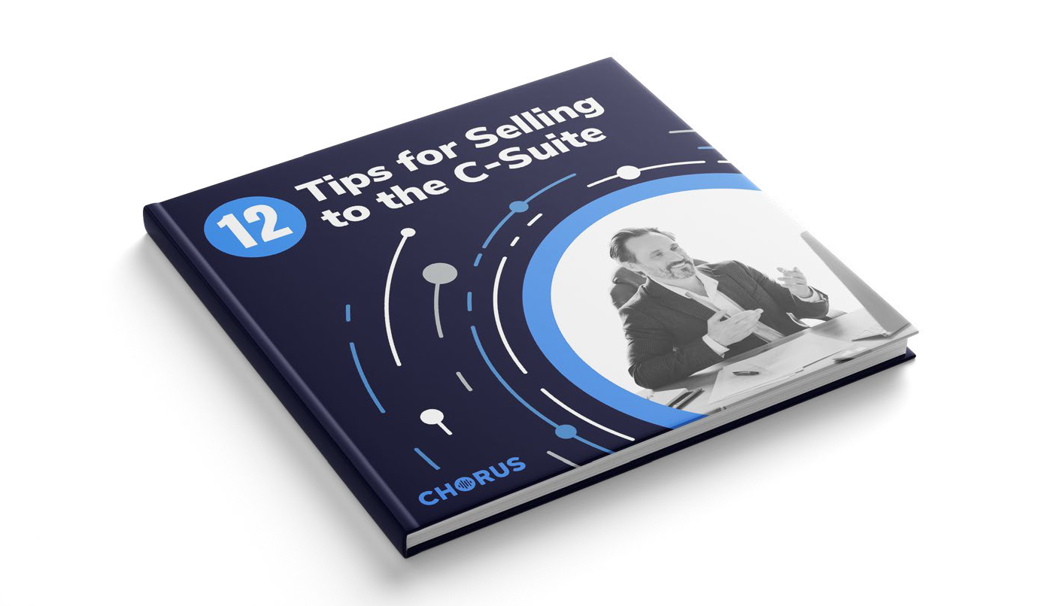

DOWNLOAD THE EBOOK